$$P\left(BuyJersey=Yes\right)=7/11$$

$$P\left(BuyJersey=No\right)=4/11$$

$$P\left(Weather | BuyJersey\right)$$

$$P\left(Weather=clear | BuyJersey=Yes\right)=3/7$$

$$P\left(Weather=clear | BuyJersey=No\right)=1/4$$

$$P\left(Weather=cloudy | BuyJersey=Yes\right)=2/7$$

$$P\left(Weather=cloudy | BuyJersey=No\right)=1/4$$

$$P\left(Weather=rainy | BuyJersey=Yes\right)=2/7$$

$$P\left(Weather=rainy | BuyJersey=No\right)=1/2$$

$$P\left(Uniform | BuyJersey\right)$$

$$P\left(Uniform=crimson | BuyJersey=Yes\right)=6/7$$

$$P\left(Uniform=crimson | BuyJersey=No\right)=0/4$$

$$P\left(Uniform=gray | BuyJersey=Yes\right)=1/7$$

$$P\left(Uniform=gray | BuyJersey=No\right)=4/4$$

$$P\left(Uniform | BuyJersey\right)$$

$$P\left(Win=Yes | BuyJersey=Yes\right)=4/7$$

$$P\left(Win=Yes | BuyJersey=No\right)=1/4$$

$$P\left(Win=No | BuyJersey=Yes\right)=3/7$$

$$P\left(Win=No | BuyJersey=No\right)=3/4$$

$$P\left(BuyJersey=Yes | Weather=cloudy, Uniform=gray, Win=Yes\right)=\frac{P\left(Weather=cloudy, Uniform=gray, Win=Yes | BuyJersey=Yes\right)*P\left(BuyJersey=Yes\right)}{P\left(Weather=cloudy, Uniform=gray, Win=Yes\right)}=αP\left(Weather=cloudy,Uniform=gray,Win=Yes | BuyJersey=Yes\right)*P\left(BuyJersey=Yes\right)=αP\left(BuyJersey=Yes\right)*P\left(Weather=cloudy | BuyJersey=Yes\right)*P\left(Uniform=gray | BuyJersey=Yes\right)*P\left(Win=Yes | BuyJersey=Yes\right)=α\frac{7}{11}*\frac{2}{7}*\frac{1}{7}*\frac{4}{7}=α*\frac{56}{3773}=α*\frac{8}{539}≈α*0.015≈0.39$$

$$P\left(BuyJersey=No | Weather=cloudy, Uniform=gray, Win=Yes\right)=\frac{P\left(Weather=cloudy, Uniform=gray, Win=Yes | BuyJersey=No\right)*P\left(BuyJersey=No\right)}{P\left(Weather=cloudy, Uniform=gray, Win=Yes\right)}=αP\left(Weather=cloudy,Uniform=gray,Win=Yes | BuyJersey=No\right)*P\left(BuyJersey=No\right)=αP\left(BuyJersey=No\right)*P\left(Weather=cloudy | BuyJersey=No\right)*P\left(Uniform=gray | BuyJersey=No\right)*P\left(Win=Yes | BuyJersey=No\right)=α\frac{4}{11}*\frac{1}{4}*\frac{4}{4}*\frac{1}{4}=α*\frac{1}{44}≈α*0.023≈0.61$$

$$α=\frac{1}{0.015+0.023}=\frac{1}{0.038}$$

It will choose “No”.

|  |  |  |  |  |
| --- | --- | --- | --- | --- |
|  | **WEATHER** | **UNIFORM** | **WIN** | **BUYJERSEY** |
| 1 | 0 | 0 | 1 | 1 |
| 2 | 0 | 0 | 0 | 1 |
| 3 | 0 | 1 | 1 | 1 |
| 4 | 0 | 1 | 0 | 0 |
| 5 | 1 | 0 | 1 | 1 |
| 6 | 1 | 0 | 0 | 1 |
| 7 | 1 | 1 | 0 | 0 |
| 8 | 2 | 0 | 1 | 1 |
| 9 | 2 | 0 | 0 | 1 |
| 10 | 2 | 1 | 1 | 0 |
| 11 | 2 | 1 | 0 | 0 |

Weather = cloudy (1), Uniform = gray (1), Win = Yes (1)

(1)(1)+(1)(1)+(1)(1)+(1)(1)=4 ≥ 0 -> BuyJersey

Untrained Perceptron will give us the result that people will Buy Jersey.

$$η=0.5$$

Round 1:

1. (1)(1)+(0)(1)+(0)(1)+(1)(1)=2 ≥ 0 -> BuyJersey <- Correct
2. (1)(1)+(0)(1)+(0)(1)+(0)(1)=1 ≥ 0 -> BuyJersey <- Correct
3. (1)(1)+(0)(1)+(1)(1)+(1)(1)=3 ≥ 0 -> BuyJersey <- Correct
4. (1)(1)+(0)(1)+(1)(1)+(0)(1)=2 ≥ 0 -> BuyJersye <- False  
   Modify Weights:  
   ΔW0=(0.5)(0-1)(1) = -0.5, W0 = 1-0.5 = 0.5  
   ΔW1=(0.5)(0-1)(0) = 0, W1 = 1  
   ΔW2=(0.5)(0-1)(1) = -0.5, W2 = 1-0.5 = 0.5  
   ΔW3=(0.5)(0-1)(0) = 0, W3 = 1
5. (1)(0.5)+(1)(1)+(0)(0.5)+(1)(1)=2.5 ≥ 0 -> BuyJersey <- Correct
6. (1)(0.5)+(1)(1)+(0)(0.5)+(0)(1)=1.5 ≥ 0 -> BuyJersey <- Correct
7. (1)(0.5)+(1)(1)+(1)(0.5)+(0)(1)=2 ≥ 0 -> BuyJersey <- False  
   Modify Weights:  
   ΔW0=(0.5)(0-1)(1) = -0.5, W0 = 0.5-0.5 = 0  
   ΔW1=(0.5)(0-1)(1) = -0.5, W1 = 1-0.5 = 0.5  
   ΔW2=(0.5)(0-1)(1) = -0.5, W2 = 0.5-0.5 = 0  
   ΔW3=(0.5)(0-1)(0) = 0, W3 = 1
8. (1)(0)+(2)(0.5)+(0)(0)+(1)(1)=2 ≥ 0 -> BuyJersey <- Correct
9. (1)(0)+(2)(0.5)+(0)(0)+(0)(1)=1 ≥ 0 -> BuyJersey <- Correct
10. (1)(0)+(2)(0.5)+(1)(0)+(1)(1)=2 ≥ 0 -> BuyJersey <- False  
    Modify Weights:  
    ΔW0=(0.5)(0-1)(1) = -0.5, W0 = 0-0.5 = -0.5  
    ΔW1=(0.5)(0-1)(2) = -1, W1 = 0.5-1 = -0.5  
    ΔW2=(0.5)(0-1)(1) = -0.5, W2 = 0-0.5 = -0.5  
    ΔW3=(0.5)(0-1)(1) = 0.5, W3 = 1-0.5 = 0.5
11. (1)(-0.5)+(2)(-0.5)+(1)(-0.5)+(0)(0.5)=-2 < 0 -> NotBuyJersey <- Correct

Weather = cloudy (1), Uniform = gray (1), Win = Yes (1)

(1)(-0.5)+(1)(-0.5)+(1)(-0.5)+(1)(0.5)=-1 < 0 -> NotBuyJersey

Trained on one round Perceptron will calculate that people won’t Buy Jersey.

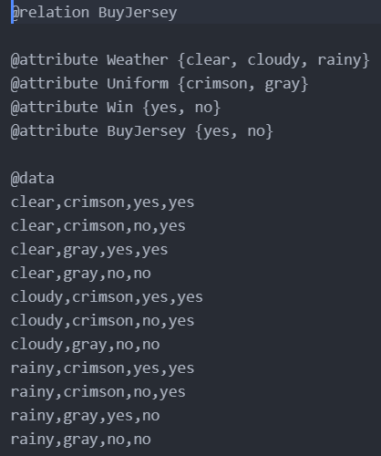

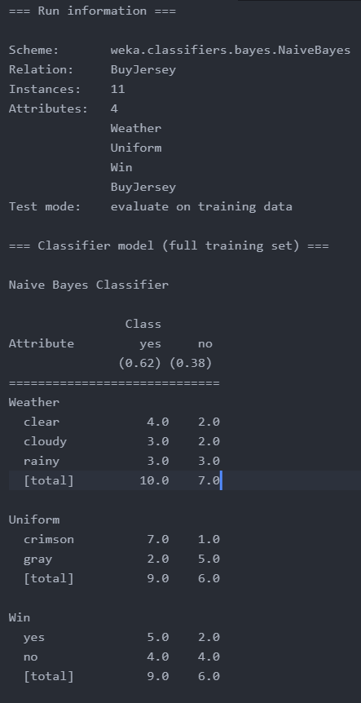

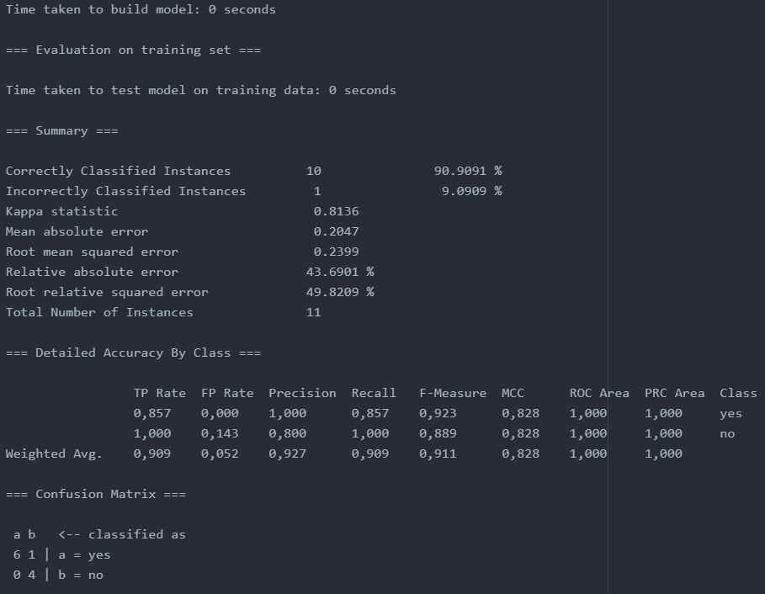

Round 2:

1. (1)(-0.5)+(0)(-0.5)+(0)(-0.5)+(1)(0.5)=0 ≥ 0 -> BuyJersey <- Correct
2. (1)(-0.5)+(0)(-0.5)+(0)(-0.5)+(0)(0.5)=-0.5 < 0 -> NotBuyJersey <- False  
   Modify Weights:  
   ΔW0=(0.5)(1-0)(1) = 0.5, W0 = -0.5+0.5 = 0  
   ΔW1=(0.5)(1-0)(0) = 0, W1 = -0.5  
   ΔW2=(0.5)(1-0)(0) = 0, W2 = -0.5  
   ΔW3=(0.5)(1-0)(0) = 0, W3 = 0.5
3. (1)(0)+(0)(-0.5)+(1)(-0.5)+(1)(0.5)=0 ≥ 0 -> BuyJersey <- Correct
4. (1)(0)+(0)(-0.5)+(1)(-0.5)+(0)(0.5)=-0.5 < 0 -> NotBuyJersey <- Correct
5. (1)(0)+(1)(-0.5)+(0)(-0.5)+(1)(0.5)=0 ≥ 0 -> BuyJersey <- Correct
6. (1)(0)+(1)(-0.5)+(0)(-0.5)+(0)(0.5)=-0.5 < 0 -> NotBuyJersey <- False  
   Modify Weights:  
   ΔW0=(0.5)(1-0)(1) = 0.5, W0 = 0+0.5 = 0.5  
   ΔW1=(0.5)(1-0)(1) = 0.5, W1 = -0.5+0.5 = 0  
   ΔW2=(0.5)(1-0)(0) = 0, W2 = -0.5  
   ΔW3=(0.5)(1-0)(0) = 0, W3 = 0.5
7. (1)(0.5)+(1)(0)+(1)(-0.5)+(0)(0.5)=0 ≥ 0 -> BuyJersey <- False  
   Modify Weights:  
   ΔW0=(0.5)(0-1)(1) = -0.5, W0 = 0.5-0.5 = 0  
   ΔW1=(0.5)(0-1)(1) = -0.5, W1 = 0-0.5 = -0.5  
   ΔW2=(0.5)(0-1)(1) = -0.5, W2 = -0.5-0.5 = -1  
   ΔW3=(0.5)(0-1)(0) = 0, W3 = 0.5
8. (1)(0)+(2)(-0.5)+(0)(-1)+(1)(0.5)=-0.5 < 0 -> NotBuyJersey <- False  
   Modify Weights:  
   ΔW0=(0.5)(1-0)(1) = 0.5, W0 = 0+0.5 = 0.5  
   ΔW1=(0.5)(1-0)(2) = 1, W1 = -0.5+1 = 0.5  
   ΔW2=(0.5)(1-0)(0) = 0, W2 = -1  
   ΔW3=(0.5)(1-0)(1) = 0.5, W3 = 0.5+0.5 = 1
9. (1)(0.5)+(2)(0.5)+(0)(-1)+(0)(1)=1.5 ≥ 0 -> BuyJersey <- Correct
10. (1)(0.5)+(2)(0.5)+(1)(-1)+(1)(1)=1.5 ≥ 0 -> BuyJersey <- False  
    Modify Weights:  
    ΔW0=(0.5)(0-1)(1) = -0.5, W0 = 0.5-0.5 = 0  
    ΔW1=(0.5)(0-1)(2) = -1, W1 = 0.5-1 = -0.5  
    ΔW2=(0.5)(0-1)(1) = -0.5, W2 = -1-0.5 = -1.5  
    ΔW3=(0.5)(0-1)(1) = 0.5, W3 = 1-0.5 = 0.5
11. (1)(0)+(2)(-0.5)+(1)(-1.5)+(0)(0.5)=-2.5 < 0 -> NotBuyJersey <- Correct

Round 3:

1. (1)(0)+(0)(-0.5)+(0)(-1.5)+(1)(0.5)=0.5 ≥ 0 -> BuyJersey <- Correct
2. (1)(0)+(0)(-0.5)+(0)(-1.5)+(0)(0.5)=0 ≥ 0 -> BuyJersey <- Correct
3. (1)(0)+(0)(-0.5)+(1)(-1.5)+(1)(0.5)=-1< 0 -> NotBuyJersey <- False  
   Modify Weights:  
   ΔW0=(0.5)(1-0)(1) = 0.5, W0 = 0+0.5 = 0.5  
   ΔW1=(0.5)(1-0)(0) = 0, W1 = -0.5  
   ΔW2=(0.5)(1-0)(1) = 0.5, W2 = -1.5+0.5 = -1  
   ΔW3=(0.5)(1-0)(1) = 0.5, W3 = 0.5+0.5 = 1
4. (1)(0.5)+(0)(-0.5)+(1)(-1)+(0)(1)=-0.5 < 0 -> NotBuyJersey <- Correct
5. (1)(0.5)+(1)(-0.5)+(0)(-1)+(1)(1)=1 ≥ 0 -> BuyJersey <- Correct
6. (1)(0.5)+(1)(-0.5)+(0)(-1)+(0)(1)=0 ≥ 0 -> BuyJersey <- Correct
7. (1)(0.5)+(1)(-0.5)+(1)(-1)+(0)(1)=-1 < 0 -> NotBuyJersey <- Correct
8. (1)(0.5)+(2)(-0.5)+(0)(-1)+(1)(1)=0.5 ≥ 0 -> BuyJersey <- Correct
9. (1)(0.5)+(2)(-0.5)+(0)(-1)+(0)(1)=-0.5 < 0 -> NotBuyJersey <- False  
   Modify Weights:  
   ΔW0=(0.5)(1-0)(1) = 0.5, W0 = 0.5+0.5 = 1  
   ΔW1=(0.5)(1-0)(2) = 1, W1 = -0.5+1 = 0.5  
   ΔW2=(0.5)(1-0)(0) = 0, W2 = -1  
   ΔW3=(0.5)(1-0)(0) = 0, W3 = 1
10. (1)(1)+(2)(0.5)+(1)(-1)+(1)(1)=2 ≥ 0 -> BuyJersey <- False  
    Modify Weights:  
    ΔW0=(0.5)(0-1)(1) = -0.5, W0 = 1-0.5 = 0.5  
    ΔW1=(0.5)(0-1)(2) = -1, W1 = 0.5-1 = -0.5  
    ΔW2=(0.5)(0-1)(1) = -0.5, W2 = -1-0.5 = -1.5  
    ΔW3=(0.5)(0-1)(1) = 0.5, W3 = 1-0.5 = 0.5
11. (1)(0.5)+(2)(-0.5)+(1)(-1.5)+(0)(0.5)=-2 < 0 -> NotBuyJersey <- Correct

Round 4:

1. (1)(0.5)+(0)(-0.5)+(0)(-1.5)+(1)(0.5)=1 ≥ 0 -> BuyJersey <- Correct
2. (1)(0.5)+(0)(-0.5)+(0)(-1.5)+(0)(0.5)=0.5 ≥ 0 -> BuyJersey <- Correct
3. (1)(0.5)+(0)(-0.5)+(1)(-1.5)+(1)(0.5)=-0.5 < 0 -> NotBuyJersey <- False  
   Modify Weights:  
   ΔW0=(0.5)(1-0)(1) = 0.5, W0 = 0.5+0.5 = 1  
   ΔW1=(0.5)(1-0)(0) = 0, W1 = -0.5  
   ΔW2=(0.5)(1-0)(1) = 0.5, W2 = -1.5+0.5 = -1  
   ΔW3=(0.5)(1-0)(1) = 0.5, W3 = 0.5+0.5 = 1
4. (1)(1)+(0)(-0.5)+(1)(-1)+(0)(1)=0 ≥ 0 -> BuyJersey <- False  
   Modify Weights:  
   ΔW0=(0.5)(0-1)(1) = -0.5, W0 = 1-0.5 = 0.5  
   ΔW1=(0.5)(0-1)(0) = 0, W1 = -0.5  
   ΔW2=(0.5)(0-1)(1) = -0.5, W2 = -1-0.5 = -1.5  
   ΔW3=(0.5)(0-1)(0) = 0, W3 = 1
5. (1)(0.5)+(1)(-0.5)+(0)(-1.5)+(1)(1)=1 ≥ 0 -> BuyJersey <- Correct
6. (1)(0.5)+(1)(-0.5)+(0)(-1.5)+(0)(1)=0 ≥ 0 -> BuyJersey <- Correct
7. (1)(0.5)+(1)(-0.5)+(1)(-1.5)+(0)(1)=-1.5 < 0 -> NotBuyJersey <- Correct
8. (1)(0.5)+(2)(-0.5)+(0)(-1.5)+(1)(1)=0.5 ≥ 0 -> BuyJersey <- Correct
9. (1)(0.5)+(2)(-0.5)+(0)(-1.5)+(0)(1)=-0.5 < 0 -> NotBuyJersey <- False  
   Modify Weights:  
   ΔW0=(0.5)(1-0)(1) = 0.5, W0 = 0.5+0.5 = 1  
   ΔW1=(0.5)(1-0)(2) = 1, W1 = -0.5+1 = 0.5  
   ΔW2=(0.5)(1-0)(0) = 0, W2 = -1.5  
   ΔW3=(0.5)(1-0)(0) = 0, W3 = 1
10. (1)(1)+(2)(0.5)+(1)(-1.5)+(1)(1)=1.5 ≥ 0 -> BuyJersey <- False  
    Modify Weights:  
    ΔW0=(0.5)(0-1)(1) = -0.5, W0 = 1-0.5 = 0.5  
    ΔW1=(0.5)(0-1)(2) = -1, W1 = 0.5-1 = -0.5  
    ΔW2=(0.5)(0-1)(1) = -0.5, W2 = -1.5-0.5 = -2  
    ΔW3=(0.5)(0-1)(1) = 0.5, W3 = 1-0.5 = 0.5
11. (1)(0.5)+(2)(-0.5)+(1)(-2)+(0)(0.5)=-2.5 < 0 -> NotBuyJersey <- Correct

Round 5:

1. (1)(0.5)+(0)(-0.5)+(0)(-2)+(1)(0.5)=1 ≥ 0 -> BuyJersey <- Correct
2. (1)(0.5)+(0)(-0.5)+(0)(-2)+(0)(0.5)=0.5 ≥ 0 -> BuyJersey <- Correct
3. (1)(0.5)+(0)(-0.5)+(1)(-2)+(1)(0.5)=-1 < 0 -> NotBuyJersey <- False  
   Modify Weights:  
   ΔW0=(0.5)(1-0)(1) = 0.5, W0 = 0.5+0.5 = 1  
   ΔW1=(0.5)(1-0)(0) = 0, W1 = -0.5  
   ΔW2=(0.5)(1-0)(1) = 0.5, W2 = -2+0.5 = -1.5  
   ΔW3=(0.5)(1-0)(1) = 0.5, W3 = 0.5+0.5 = 1
4. (1)(1)+(0)(-0.5)+(1)(-1.5)+(0)(1)=-0.5 < 0 -> NotBuyJersey <- Correct
5. (1)(1)+(1)(-0.5)+(0)(-1.5)+(1)(1)=1.5 ≥ 0 -> BuyJersey <- Correct
6. (1)(1)+(1)(-0.5)+(0)(-1.5)+(0)(1)=0.5 ≥ 0 -> BuyJersey <- Correct
7. (1)(1)+(1)(-0.5)+(1)(-1.5)+(0)(1)=-1 < 0 -> NotBuyJersey <- Correct
8. (1)(1)+(2)(-0.5)+(0)(-1.5)+(1)(1)=1 ≥ 0 -> BuyJersey <- Correct
9. (1)(1)+(2)(-0.5)+(0)(-1.5)+(0)(1)=0 ≥ 0 -> BuyJersey <- Correct
10. (1)(1)+(2)(-0.5)+(1)(-1.5)+(1)(1)=-0.5 < 0 -> NotBuyJersey <- Correct
11. (1)(1)+(2)(-0.5)+(1)(-1.5)+(0)(1)=-1.5 < 0 -> NotBuyJersey <- Correct

Round 6:

1. (1)(1)+(0)(-0.5)+(0)(-1.5)+(1)(1)=2 ≥ 0 -> BuyJersey <- Correct
2. (1)(1)+(0)(-0.5)+(0)(-1.5)+(0)(1)=1 ≥ 0 -> BuyJersey <- Correct
3. (1)(1)+(0)(-0.5)+(1)(-1.5)+(1)(1)=0.5 ≥ 0 -> BuyJersey <- Correct
4. (1)(1)+(0)(-0.5)+(1)(-1.5)+(0)(1)=-0.5 < 0 -> NotBuyJersey <- Correct
5. (1)(1)+(1)(-0.5)+(0)(-1.5)+(1)(1)=1.5 ≥ 0 -> BuyJersey <- Correct
6. (1)(1)+(1)(-0.5)+(0)(-1.5)+(0)(1)=0.5 ≥ 0 -> BuyJersey <- Correct
7. (1)(1)+(1)(-0.5)+(1)(-1.5)+(0)(1)=-1 < 0 -> NotBuyJersey <- Correct
8. (1)(1)+(2)(-0.5)+(0)(-1.5)+(1)(1)=1 ≥ 0 -> BuyJersey <- Correct
9. (1)(1)+(2)(-0.5)+(0)(-1.5)+(0)(1)=0 ≥ 0 -> BuyJersey <- Correct
10. (1)(1)+(2)(-0.5)+(1)(-1.5)+(1)(1)=-0.5 < 0 -> NotBuyJersey <- Correct
11. (1)(1)+(2)(-0.5)+(1)(-1.5)+(0)(1)=-1.5 < 0 -> NotBuyJersey <- Correct